# Topology optimisation: more computational power, more resolution

Current algorithms for topology optimisation have remained the same for over 30 years. In the simplest terms, a structure is broken down into small finite mesh elements and an density variable is assigned to each element. An optimiser algorithm varies the density variable, while monitoring the total compliance of the structure. The optimiser will try to minimize compliance by varying the density variable, while encouraging the variables to tend to either a value of 0 or 1. A value of 0 indicates empty space while 1 indicates the presence of material.

Current computational power has been increasing exponentially by the year, allowing us to create higher and higher resolution topology optimised structures. A good case study is the paper published in the journal Nature where researchers optimised the structure of a Boeing 777 wing using a super computer. The authors claim an increase in fidelity of a two orders of magnitude higher than previously reported. Their model uses over a billion “voxels”, mesh elements whose density values are optimised by the optimiser. However, it must be noted that the authors see weight savings of only 2-5%, but it could translate to into a reduction in fuel consumption of about 40–200 tonnes per year per aeroplane.

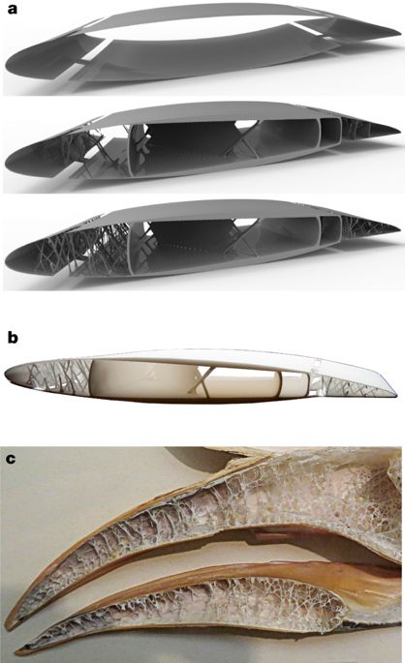

# Topology optimised Infill for 3D printing

One very popular method of additive manufacturing is the Fused deposition model(FDM) which works by layer-by-layer deposition of a feedstock plastic filament material extruded through a nozzle. A key requirement of the FDM method is infill, structures to deposit material upon. Current methods do not allow depositing material in thin air, and therefore has to be deposited upon either the printer’s base plate or on infill structure. 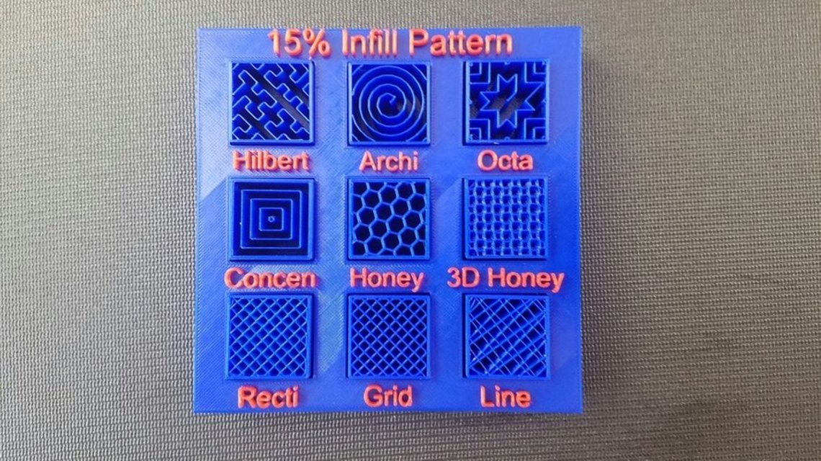

Current algorithms in commercial printers use regular patterned infill structures, such as the honey comb structure or the gyroid structure. There is a large scope for optiomised the infill structure themselves. Research into this area is currently being led by Dr Jun Wu of TU Delft, who has led a team to design the infill structures based on loading conditions. This advance in design could lead significant weight savings.

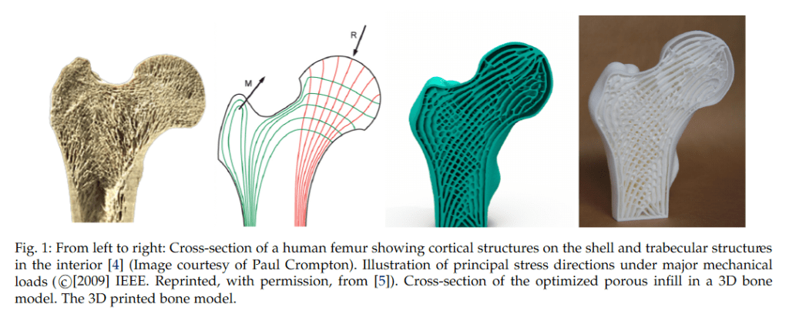

More references are on [my (Medad’s) article](http://medadnewman.co.uk/2019/09/27/dr-jun-wu-topology-optimised-infill/?customize_changeset_uuid=156ed959-2673-4cf5-a56a-a83cf804e088&customize_autosaved=on).

# The marriage of electronics and mechanical structures

With every tighter requirements for tighter integration

## Topology otimsed electronics